AI-LEND SENSE: PREDICTIVE AND EXPLAINABLE LOAN DECISION SYSTEM

B. Deepthi  UG Student, Department Of CSE, CMR Technical Campus, Hyderabad, Telangana, India – 501401 deepthibarma112@gmail.com | G. Bhavya Bhargavi  UG Student, Department Of CSE, CMR Technical Campus, Hyderabad, Telangana, India – 501401 gorlebhavya18@gmail.com | B. Balaji Nayak  UG Student, Department Of CSE, CMR Technical Campus, Hyderabad, Telangana, India – 501401 badavathbalaji028@gmail.com
Dr. K. Srujan Raju,  Department Of CSE,  CMR Technical Campus, Hyderabad, Telangana, India – 501401 ksrujanraju@gmail.com | D. Sandhya Rani  Assistant Professor, Department of CSE, CMR Technical Campus, Hyderabad, Telangana, India – 501401  davu.sandhya@gmail.com | M. Madhusudhan Assistant Professor,Department of CSE, CMR Technical Campus,  Hyderabad, Telangana, India – 501401 madhusudhan.cse@cmrtc.ac.in

ABSTRACT

AI-Lend Sense is a loan decision assistant that's easy to understand and use. It helps people figure out loans in a way. Let us be real: banks need loans to make money. It is hard to know who will pay back the loan on time. The old way of checking loans takes a time there is a lot of paperwork and sometimes people do not even know why they were not given a loan. AI-Lend Sense wanted to make this process better. Our tool uses information like a steady income, a stable job, your CIBIL score, how much debt you have compared to your income and verified bank information and the loan amount you want. We put all this information into computer programs like Logistic Regression, Decision Tree and Random Forest. These programs help us make decisions. In a few seconds AI-Lend Sense can tell us if we should say yes or no to a loan. What makes us different is that we are transparent. The people who apply for a loan get a report that is just, for them and this report breaks down the decision that was made about their loan. The lenders can see exactly what is driving each decision so they know that the loan process is fair and based on information. The loan process runs in a clean and easy to use system web app. Borrowers can apply, see insights from the data, and download a detailed analysis of their results. Conversely, the bank managers receive an “admin fee” for each transaction. Based on this, it blends accurate forecasting with simple honesty. Explanations, AI- Lend Sense allows lending to occur faster by enabling AI to more equitable, and even justifiable for the banks and customers alike.
Keywords - Loan Prediction, Logistic Regression, Random Forest, Decision Tree, Explainable AI.

I. INTRODUCTION

The truth is that no one has the time to wait for weeks to even have their questions answered on a loan. However, many banking institutions are also still buried under piles of paperwork and old guts to even deliver a yes or no to the awaiting masses. A yes or no response will only send others on a road to frustration for banking institutions.

The moment you touch down on our Home page, a friendly web portal walks you through step by step. You not only get a chance to test eligibility but also get to see data for your decision or move on for some system-level information. The 'Apply for Loan' form picks up just what it needs—you, your information, your PAN/Aadhaar, your banking information, and finally, your financial information—and then tests it out on three good models (Logistic Regression, Decision Tree, Random Forest).

But this is where our service truly sets itself apart. With our explainable AI powered by LIME, we provide a readable explanation for every single decision. We’ll start with the decision itself, its confidence level, the risk factor, the votes cast by the individual model, the results of fairness tests, and explanations like “loans are large,” “credit scores are low,” and “debt burden weighs heavily.” We also want to help you increase the chances of a better decision the next time around.

Admins receive a “Dashboard to monitor how models are performing, approval rates, and whether there is any kind of bias creeping in.” The “Dataset Explorer allows anyone to view data that drives the entire process.” In other words, AI Lend Sense puts accuracy, transparency, and ethics above everything else because AI Lend Sense is one of the few applications of AI that earns trust by weeding out bias to make taking out a loan more characteristic of human behavior.

II. LITERATURE REVIEW

What early loan decisioning systems were trying to fix was the slowness of the manual process. What they replaced it with were simple rule- based decisioning systems. What Thomas and others did was let the experts decide on hard thresholds for things such as income, credit scores, and payments. Well, sure, this moved the process a little quicker, but they were very rigid.
And once more data started pouring in, then statisticians leaped on to Logistic Regression. Hand and Henley demonstrated that you could actually forecast who'd default by looking at income, job status, and credit history. These models were easier to explain than the old rule-based stuff, but they were stuck with linear relationships—and real-world finance is just way messier and more tangled than that.

And then came the tree-based algorithms Breiman’s Decision Trees broke down applicants into tidy little boxes governed by rules. These were better, clearer, and more effective than purely statistical methods. But the drawback here is that these algorithms tend to overfit, especially in cases where you lack data or lack balanced data. Then followed ensemble methods like Random Forests, courtesy of Liaw & Wiener. You now had several trees working together, wherein the predictions were more accurate and not shaky. The catch-the models now became "black boxes." Lenders and borrowers couldn't see why a decision landed the way it did.

But then came Explainable AI (XAI), which changed all that. LIME by Ribeiro began to concentrate on which aspects were playing the lead role in arriving at a particular result. Results such as poor credit ratings or excessive debt. People were more comfortable around this process. But to be honest, most of them were still somewhat technical. On top of all that, fairness emerged as a concern (due to Barocas et al.). Automated models to compute credit scores can reinforce gender or geolocation bias. It was proposed that fairness models be used, but essentially, most of these tools simply monitor bias occurrences in the background. Nothing to look at to see where things stand.

Lately, online platforms, for example, one developed by Chen and his teammates, have started integrating data entry with predictive tools and admin interfaces. Yet they also fail to offer decision reports and feedback to the applicants. The problem is that every solution does one thing amazingly well but hardly any solution does everything well AI-Lend Sense aims to do in its attempt to fill the solution gap in predicting eligibility, justifying its results, checking for justice in its verdict, allowing you to peep into its data, and providing a report for applicants that’s analytically correct. The aim is simple: integrate ‘ensemble models, XAI, justice checks, data transparency, and interactive reports in one crystal clear, crystal transparent loan decision solution'.

III. METHODOLOGY

AI-Lend Sense makes getting a loan really simple. It goes through every step of the way and makes sure everything is fair for everyone no matter if you are the one asking for the loan or if you work at the bank. AI- Lend Sense does everything automatically. Tells you why it makes certain decisions. This way AI-Lend Sense gets rid of a lot of the confusion that people usually have when they are trying to get a loan approved by the bank. AI Lend Sense is really good, at explaining things so you know what is going on with your loan. Here is Here is what happens when you want a loan. You go to the website. Click on the button that says Apply for Loan. The system will ask you for some information. They need to know your name. They need to see your government IDs like PAN or Aadhaar. They also need to know about your bank and how money you earn. The system wants to know how long you have been working at your job. They need to know about your debt and how it compares to the money you earn.

They need to know how money you want to borrow and for how long. You also have to tell them why you need the loan. When you give the system all this information it has what it needs to make a decision, about your loan application.

When you send in your details AI-Lend Sense looks over everything to find any mistakes or missing information. It cleans up the data. Gets it ready to use. Then AI-Lend Sense uses machine learning. Your application goes through three models: Logistic Regression, Decision Tree and Random Forest. Each of these models Logistic Regression, Decision Tree and Random Forest tries to make a decision based on what it has learned from applications.

But here is the part: you do not just get a plain yes or no. The system uses AI with LIME to actually show you why it made its decision. Maybe you asked for a loan your credit score is not great you owe a bit too much money already or you have not been in your job for a long time. Whatever the reason the Explainable AI system lays it out in language and with clear visuals so you can understand why the Explainable AI system made its decision, about your loan.

Fairness is very important. The system looks at itself to see if it is being fair. It uses checks to make sure things like gender or where you are from do not affect your results. The system checks for fairness by running checks. If something does not seem right, with the fairness of the system it will catch the problem with the fairness of the system.

At the end you get a Decision Analysis Report. This report tells you if you got the loan or not. It also tells you how sure the system was about its answer. The Decision Analysis Report shows what risk group you are in. It even shows how each model voted on your loan. You will see why you got that result.

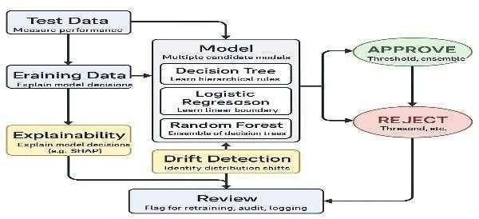
Fig.1. Workflow of the AI-Based Loan Approval System

IV. IMPLEMENTATION

We made -Lend Sense to make loan decisions better and more fair. The system is easy to understand and works in a way. It is made up of parts that work together so it can check if someone is eligible for a loan automatically explain the reason for every decision in a way that is easy to understand and make sure everything is fair. You do not have to do a lot of things to use AI- Lend Sense. You can just open it in your internet browser. Whether you are someone who is applying for a loan from AI-Lend Sense or you are reviewing loan applications or you are in charge of AI-Lend Sense, as an administrator AI-Lend Sense is ready for you to use.

Testing was really easy. The system works well on any computer. The system runs smoothly long as you have Windows 10 or a newer version. We tried the system on our computers and, on the cloud to see how it works in real life. We wanted to make sure the system works well and does not have any problems when many people use it. For the end we chose React, Vite and TypeScript. The front end is quick and responsive. It gives users a lot of things like a Home Page, a Loan Application Form, a Dataset Explorer, an Admin Dashboard and a Decision Analysis Report. When you send in your application the system starts working on your information away. It takes care of missing parts makes sure the numbers are correct and puts things into groups. One important thing it does is calculate your Debt-to- Income ratio. Your Debt-to-Income ratio is found by taking your monthly debt and dividing it by your gross monthly income. When the data is ready it goes to the machine learning models.

We use three machine learning models: Logistic Regression, Decision Tree and Random Forest. The Logistic Regression model combines your information, like your income, your credit score the loan you requested and your job history with some learned weights and a bias. If the Logistic Regression model thinks you have a chance of being approved and this chance is, above a certain level then you are approved by the Logistic Regression model.
If not the Logistic Regression model says no.
z = w1x1 + w2x2 + ⋯ + wnxn + b
P (Approval) = $1/(1+e^{-z})$

A Decision Tree looks at the data. Splits it based on the most important thing, about it using something called the Gini Index to tell the good candidates from the bad ones. Random Forest goes one step further. It makes a lot of these trees. Then asks each of them what they think and it decides what to do based on what most of the Decision Trees say.

Final Decision = Majority Vote of All Trees.

We wanted every decision to be clear, so we used Explainable AI (XAI) with LIME. LIME breaks down each prediction, highlighting which details— like a low credit score or a high DTI—moved the needle. You see these right in your Decision Analysis Report, written in plain terms.
It applies fairness constraints such as demographic parity to ensure that the approval rates are not affected by attributes that should not matter.
We looked at the system, with loan cases and fake ones. We tried the system with real and fake loan situations. To find out how good it was we checked how accurate it was, how precise it was, how well it remembered things and its F1-score. The goal was to build a system that's smart, fair and easy to understand so the loan system is smart, fair and easy to understand. These evaluation results show that the system does a lot more than just make predictions. It makes decisions and reliable decisions. The system balances being precise and getting everything through something called the F1-score. This means the model does not send out alerts and it does not miss important cases. This is very important when the system is actually being used in the world. The system also makes sure its decisions are fair. The system was tested with data and fake data to make sure it works well in different situations. The evaluation results show that the system is robust and works with different types of data. The system makes decisions and this is because it uses the evaluation results to make sure it is working correctly. These things show that the way we want to do this is good because it gives the answers and it is fair, to everyone.
True Positive (TP): Disaster correctly identified— alert and allocation triggered.
False Positive (FP): Disaster incorrectly detected .
False Negative (FN): Disaster missed by the system.
True Negative (TN): No disaster, system gets it right Evaluation Metrics.
Precision = ^{𝑇𝑃}
𝑇𝑃+𝐹𝑃

Recall = ^{𝑇𝑃}
𝑇𝑃+𝐹𝑁

F1-Score = $2*\frac{precision*recall}{precision+recall}$
Accuracy = $\frac{TP+TN}{TP+TN+FP+FN}$

V.RESULT AND ANALYSIS

We tried out the AI-Lend Sense system to see how it works with loan applications. We wanted to know if it can tell us who will get a loan and why. These are good results. This system is able to approve a loan without being unjust and complex. We evaluated absolutely everything. We reviewed how people are using this website. We reviewed what the system is predicting. We reviewed what it provides for explanations. We reviewed even the tools administrators are using to monitor what is happening. The AI-Lend Sense system is a good system, doing what it is designed for. It is able to approve a loan. Explain why it is choosing those specific options. Let us begin with the top. The Home Page is where everything starts on a website.
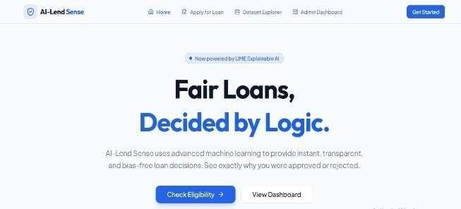
Tone--everything is easy to find. You can jump straight to eligibility criteria, apply, or dig through datasets. Click "Get Started" and you are in the application form.

Fig. 2. Home Page of Loan Approval System.
It is comprehensive, covering a wide array of fields in the loan application form: personal information, government- issued IDs such as PAN or Aadhaar, bank account details, financial information (income levels, debt obligation), and complete details of the loan applied for-amount needed and tenure required.
In case of any incomplete or incorrect information, it gets flagged immediately by the system itself, even before submission. That keeps the data clean and the predictions sharp.
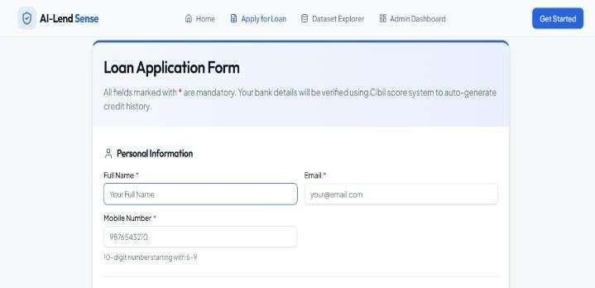

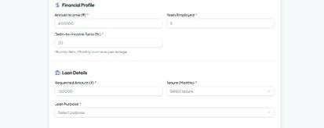


Fig.3. User Loan Application Form For Loan Approval System
When you click on "Verify & Analyze Eligibility" the system starts doing its job. It gives you a Loan Decision Analysis Report. This is where things get interesting. The Loan Decision Analysis Report is where you can see what is happening in regards to your loan. Three separate computer models, Logistic Regression & Decision Tree, as well as Random Forest, examine your data. They then make a decision about whether you can have the loan or not. The Loan Decision Analysis Report does not simply provide you an answer yes or no for the loan.
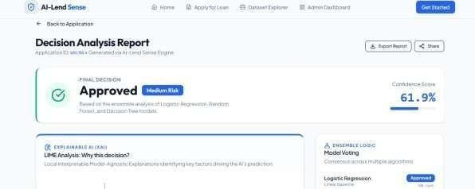
They also provide you with a score indicating how certain the computer is about its decision.

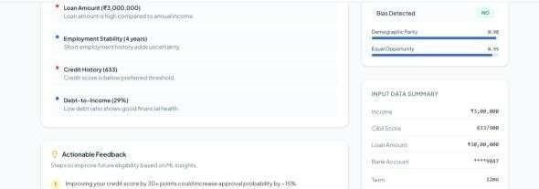
Fig.4. Loan Approval Result Page.

Fig.5. Loan Approval Result Page displaying a Result Description.

"Explanation" really shines in this case. "LIME" allows it to point out what it liked or didn’t like about your application, in graphs and easy-to- understand language. If it denied your application, it’ll show you what to work on next time. "It increases trust, which trumps algorithms that simply respond "yes" or "no" without an explanation".
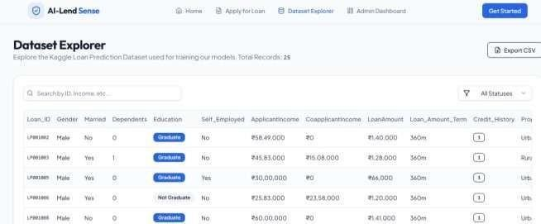
If we want to dig deeper, the Dataset Explorer opens up the real data used to train and test the models. You could look at things like income, credit score, loan amount, approval status-there is nothing hidden or shady, so it shows you exactly how the decisions get made.

Fig.6. Data Set Exploration of Loan Approval System

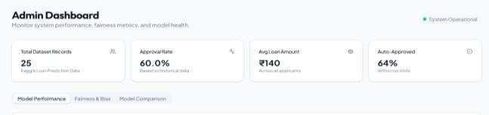
Fig.7. Model Performance Monitoring Dashboard of Loan Approval System.
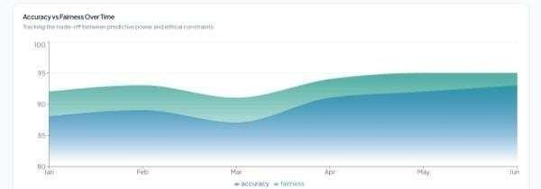

Fig.8. Model Performance Over Time.

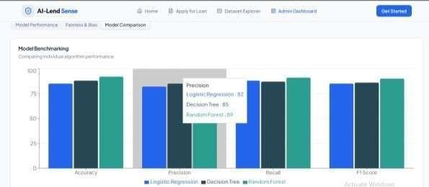

Fig.9. Machine Learning Model Comparison Graph.

V. CONCLUSION

AI-Lend is a completely new way of undertaking loan approvals. That is why it is impressive: bye-bye to lengthy processes and ambiguous approval and disapproval of loans because this is a system employing machine learning and Explainable AI. This takes away the clutter and vagueness surrounding approval and disapprovals of loans. A considerable amount of work is done compared to the former procedure. There is no tiresome loan evaluation process since it acts narrowly.
At the core of AI-Lend Sense are models such as Logistic Regression, Decision Trees, and Random Forests. An individual has come up with a recipe that will not affect predictability with regards to results from risk assessment. In fact, it will not fail even with tough assessments. After the individual has placed a loan request, there will be a compilation of everything that is needed for placing across a loan request. These will include details such as personal details, government-approved identification verification, banking details, history, and amounts borrowed from personal loans.
However, the thing that makes this tech even more interesting is LIME, and it really takes the black box out from artificial intelligence. They are not inventing a language; they are illustrating what the most important variables are out of the ones that are involved. The scales of justice had finally been turned in their favor, and they are not sneaky because you can literally see what factors went into a given decision. They are even making sure that it is not prejudiced against any population.
Regarding speed, the AI-Lend Sense outpaces the traditional approach and delivers much better consistency in trialing experience with tools in the possession of the user in the form of the Dataset Explorer and the Admin Dashboard, which enables the user to dig deeper into the numbers, assess how models perform, and monitoring approval rates as well as fairness. AI-Lend Sense's role extends well beyond the fail-forward and futuristic nature of the technology.

VI. REFERENCES

[1] X. Zhu, J. Wang, and Y. Li (2023) dive into using machine learning and LIME to predict loan defaults. They don’t just chase accuracy— they actually explain their predictions, which matters if you want to trust the results. You’ll find this one in Heliyon on ScienceDirect.
[2] X. Q. Chen, Y. Wang, and L. Zhang (2023) scrutinize the phenomenon of explainable AI in finance.They map the research terrain and gopher some details,so if you are looking for a bird’s-eye view delivered with some depth theirs is definitely a nice pick in the Journal of Financial Data Science.
[3] B. H. Misheva (2021) delves into the detailed workings of explainable AI for credit risk. She covers both instance-level tools like LIME and broader approaches such as SHAP, demonstrating how they contribute to rendering credit scoring models interpretable. You'll find this preprint on arXiv.
[4] J. Cerneviciene and colleagues (2024) pull together a systematic review on explainable AI in finance. If you want the lay of the land—and not just a few scattered studies—this Springer review in Applied Intelligence gives you a comprehensive overview.
[5] S. Mestiri 2024 contrasts credit scoring with ML and DL. Instead of merely picking a winner, they delve into how each performs so that you have a real view of what works (and what doesn’t). This was published by AIMS Press.
[6] In 2024, an arXiv paper experimented with fairness- aware machine learning for credit scoring. They did not simply compute the accuracy; they also evaluated how fair the algorithms are when applied to real-world lending data.
[7] R. Jinad et al. (2024) delve into the functioning of interpretive and transparent machine learning models, the interpretability methods available, and how they might be evaluated, so do check their work in MDPI Electronics for further explorations into the black box.
[8] X. Zhang and team (2025) tenders a comparative analysis among various tree-based ensemble models such as Random Forest and XGBoost for predicting defaults in loan transactions, all of which are contained in MDPI Systems.
[9] C. Molnar, "Interpretable Machine Learning: A Guide for Making Black Box Models Explainable," 2nd ed., Leanpub, 2022.
[10] R. Guidotti et al., “A survey of methods for explaining black box models,” ACM Computing Surveys, vol. 51, no. 5, pp. 1–42,2019.
[11] A. Bussmann, P. Giudici, D. Marinelli and J. Papenbrock, “Explainable AI in credit risk management,” Journal of Financial Data Science, vol. 3, no. 3, pp. 28–45, 2021.
[12] M. T. Ribeiro, S. Singh, and C. Guestrin, “Why should I trust you? Explaining the predictions of any classifier,” in Proceedings of the 22nd ACM SIGKDD International Conference on Knowledge Discovery and Data Mining, 2016,pp. 1135–1144.
[13] S. Barocas, M. Hardt, and A. Narayanan, Fairness and Machine Learning: Limitations and Opportunities, Cambridge University Press, 201.
[14] T. Chen and C. Guestrin, “XGBoost: A scalable tree boosting system,” in Proceedings of the 22nd ACM SIGKDD International Conference on Knowledge Discovery and Data Mining (KDD), 2016, pp. 785–794.
[15] H. Li, Y. Cao, and S. Wang, “Deep learning for credit scoring: Performance evaluation and interpretability analysis,” Expert Systems with Applications, Elsevier, vol. 198, 2022.

